# Introduction

In this project, we design CuK converter respect with these desired values:

* Input Voltage: 9 V
* Output Voltage: -12 V
* Output Current: 3 A
* Switching frequency: 100 kHz
* Max. Output voltage ripple: 2%

# Part a. Choosen a Suitable Capacitor and Inductance That Can Produce the Output within Given Tolerances Under Under CCM.

|  |  |
| --- | --- |
| Input Voltage | 9V |
| Output Voltage | -12V |
| Output Current | 3A |
| Switching Frequency | 100 kHz |
| Max. Output Voltage Ripple | 2% |

For a CuK converter with above specs. operating in CCM, the duty cycle cycle is given below:

D = $\frac{Vo}{Vo+Vd}$ = $\frac{12}{12+9}$ = 0.5714

By assume ideal condition, Poutput=Pin

Then, Id = Io*= = 4 A Id = Io * = 4 A

## Selection of Inductors

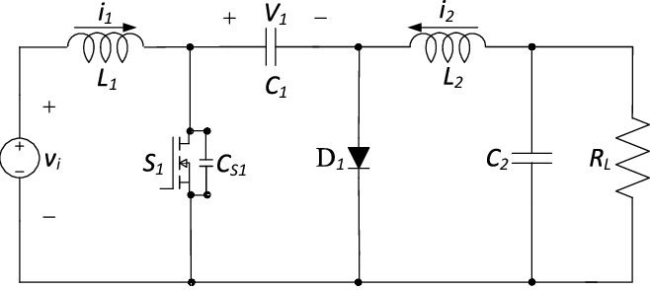

With respect to figure x which is design of Cuk. Average current value of L2 is equal to output current Io . Similarly, average current value of L1 is equal to input current Id :

IL1 = Id = 4 A

IL2 = Io = 3 A

To calculate inductance values ΔIL1 assumed tobe 30% of IL1:

ΔIL1 = 0,3*5 = 1,5 A

As a proporties of CuK converter ΔIL1 = ΔIL2 = 1,5 A

During switch is on, inductor voltage-current equation yields

## VL1 = L1.